**DEEPFAKE DETECTION USING DEEP LEARNING**

**Guide : Dr. Sairamesh L Name : Gurunathan M**

**Roll No : 2019202015**

**Abstract :**

The increasing sophistication of smartphone cameras and the availability of good internet connection all over the world has increased the ever-growing reach of social media and media sharing portals have made the creation and transmission of digital videos more easy than ever before. The growing computational power technology, "DeepFake" are produced by deep generative adversarial models that can manipulate video. Spreading of the DF over the social media platforms have become very common leading to spamming and peculating wrong information over the platform. These types of the DF will be terrible, and lead to threating, misleading of common people. So our method detects such artifacts by comparing the generated face areas and their surrounding regions by splitting the video into frames and extracting the features with a ResNext Convolutional Neural Network (CNN) and using Long Short Term Memory(LSTM) capture the temporal inconsistencies between frames introduced by GAN during the reconstruction of the DF. By these way, we can predict the video is DeepFake or Real.

**Introduction:**

Deep learning is a branch of machine learning which is completely based on artificial neural network, as neural network is going to mimic the human brain so deep learning is also a kind of mimic of human brain. In deep learning, we don’t need to explicitly program everything. Machine learning allows a system to learn and improve from experience automatically. Deep learning is an application of machine learning that uses complex algorithms and deep neural nets to train a model.

**Problem Statement:**

To design and develop a deep learning algorithm to classify the video as fake or real.

**Objective:**

**Architecture Diagram:**

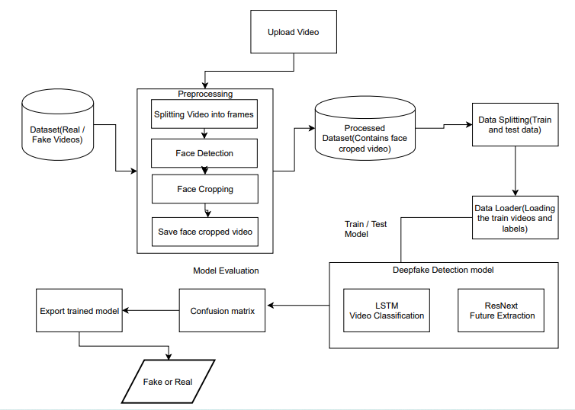

**Architecture Explanation:**

**List of Modules:**

**Description of Modules:**

**References:**

* <https://www.kaggle.com/competitions/deepfake-detection-challenge/data>
* <https://ayushbasral.medium.com/deepfake-detection-using-resnxt-and-lstm-bcc08c086f84>
* <https://engineering.purdue.edu/~dgueraco/content/deepfake.pdf>
* <https://arxiv.org/pdf/1909.11573.pdf>
* <https://www.ijitee.org/wp-content/uploads/papers/v9i6/E2779039520.pdf>